Chapter 17, Solution 41.

The full-wave rectified sinusoidal voltage in Fig. 17.77(a) is applied to the lowpass filter in Fig. 17.77(b). Obtain the output voltage v_{o}(t) of the filter.

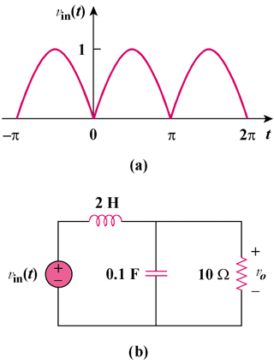

Figure 17.77
For Prob. 17.41.

Solution

For the full wave rectifier,

T = π, ω_{o} = 2π/T = 2, ω_{n} = nω_{o} = 2n

Hence
v_{in}(t) =

For the DC component,

V_{in} = 2/π

The inductor acts like a short-circuit, while the capacitor acts like an open circuit.

V_{o} = V_{in} = 2/π

For the nth harmonic,

V_{in} = [–4/(π(4n² – 1))]∠0°
2 H becomes jω_{n}L = j4n
0.1 F becomes 1/(jω_{n}C) = –j5/n
Z = 10||(–j5/n) = –j10/(2n – j)
V_{o} = [Z/(Z + j4n)]V_{in} = –j10V_{in}/(4 + j(8n – 10))
=
=

Hence
v_{o}(t) = volts
where
A_{n} =

θ_{n} = 90° – tan^{–1}(2n – 2.5)

